**Home Pages**



**We are ready to help you**

**We Are the Best Academic Help**

We are the finest academic assistant company globally because we promise anonymity and continuous contact with our customers.



**We are here to support you**

**Exclusive Assistance in Writing Services**

Thousands of students remember Primedissertation.co.ukas help for education at every level of their study.

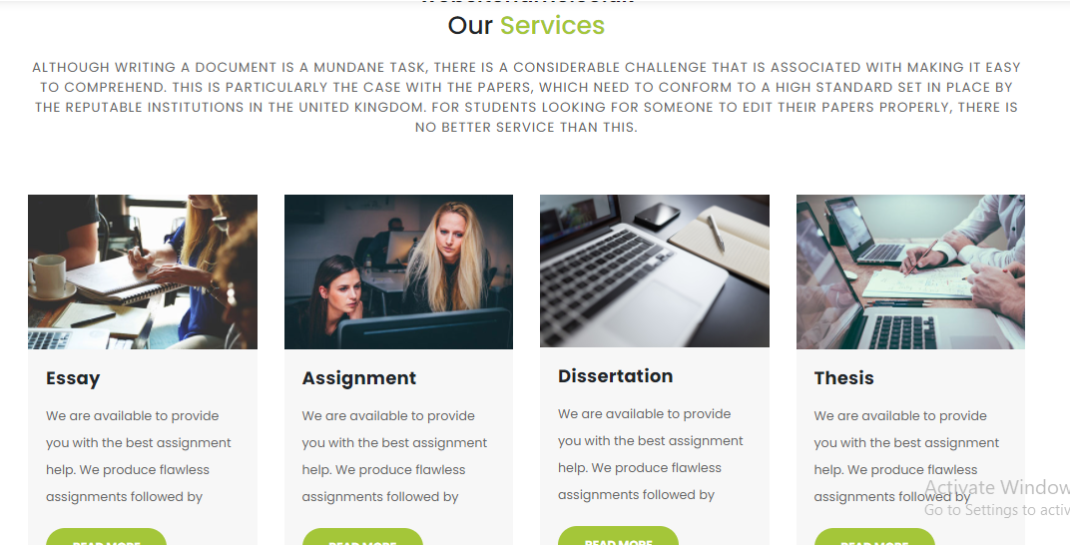

**Our Services**

We are a decade-old business that has assisted thousands of students to achieve their academic objectives. If you want, we can improve your academic career by giving you the assistance you need. We have a staff of experts in various subjects that can help in according to your needs. We provide the most satisfactory services to write essays, dissertations and write any kind of job.

**Essay**

At Primedissertation.co.uk, we provide university, college and high school students the most exemplary written support for all kinds of essays. We have the finest quality authors to create the best essay on any topic.

**Assignment**

Primedissertation.co.ukwritten assignments service is extremely simple to get. We support research papers, reviews of literature and any other tasks you want. Our finest written assignments will be given.

**Dissertation**

The finest help to write a dissertation is Primedissertation.co.uk. For dissertation, we provide doctoral students a highly competent expert. Our experts bring originality to your dissertation writing. So send us your dissertation instead of jeopardizing all the hard work you've put in, and receive a unique paper in exchange.

**Thesis**

Primedissertation.co.uk experts are qualified professionals with enough training and thesis papers to handle any topic matter. Their primary objective is to create a flawless and accurate thesis paper. Our experts greatly believe in providing quality.

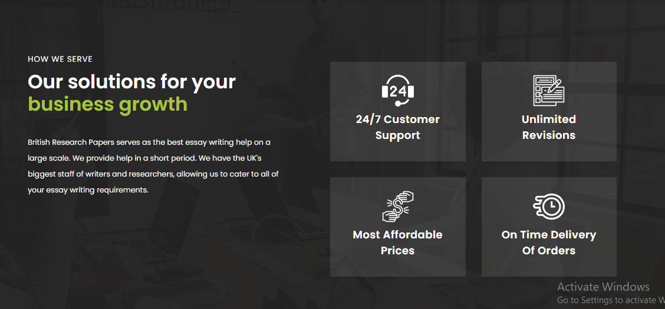

**How We Serve?**

It is essential for **Primedissertation.co.uk**, to come up with a solution to all of your problems in academic life and retain your confidence. We ensure that we fit into your restricted budget while arranging our service costs. We strive to be extremely flexible with our academic services and provide free revisions to our work if you discover any mistakes. **Primedissertation.co.uk** gives you high- quality assignment.

**27/ Customer Support**

**Authenticity guarantee**

**On-Time Delivery**

**Most Affordable Prices**

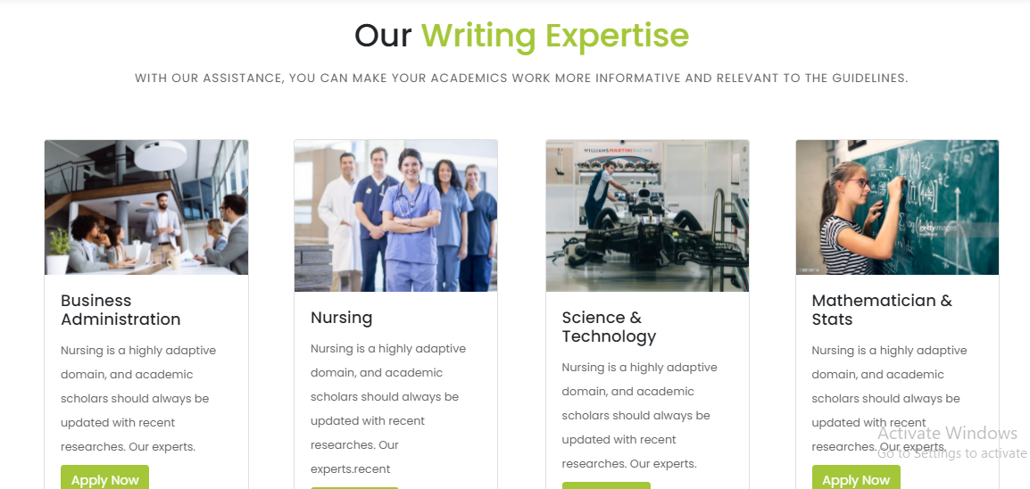

**Areas of Expertise**

For all these written assistance, we cover every topic and area. **Primedissertation.co.uk’s** experts can shape your paperas you cannot imagine.

**Business Administration**

Students who attend business schools must compete with dozens of jobs throughout their academic journey. The capacity to make high-quality assignments within the timeframe is regarded as a hallmark of academic achievement and scholarship. But if you are unable to write assignments of high quality, Primedissertation.co.uk is here to help you. Our top-level writing assistance earned much acclaim for business homework responses.

**Nursing**

Nursing is a wide field of study. Therefore, students’ assignments are always diverse. During your education, you will need to write several different tasks. This may be very frightening, particularly for first-timers. By outsourcing the job to us, you can eliminate this tension. Our experts enable us to tackle all kinds of tasks without any concern.

**Psychology**

Writing profound tasks is one of the most important talents a major in psychology may possess. As a student, most of the courses you take involve a lot of writing. So, Primedissertation.co.uk will be helpful for an online psychology assignment. We provide guidance, assistance and advice on how to accommodate your psychological tasks. If you have struggled to create high-quality homework, our experience can help you improve your abilities.

**Medical Science**

Medical science is a topic that needs you to understand and comprehend ideas in detail. To keep up with your other tasks and hobbies, an online service such as **Primedissertation.co.uk** reduces your academic strain. Our professionals are scientists with an experienced background in thorough research and outstanding work.



**About Us**

**Get to Know about Primedissertation.co.uk**

**Primedissertation.co.uk** has the pleasure of being the best assignment assisting service in the UK since we offer assignment services with a guarantee of privacy and ongoing contact at an affordable cost. We have around 50 PhD certified specialists to help students in different fields. We are always ready to assist you in your hard courses. Our team are committed and enthusiastic assignment workers who are keen to provide great assistance so that all the pupil can deal with difficult tasks.

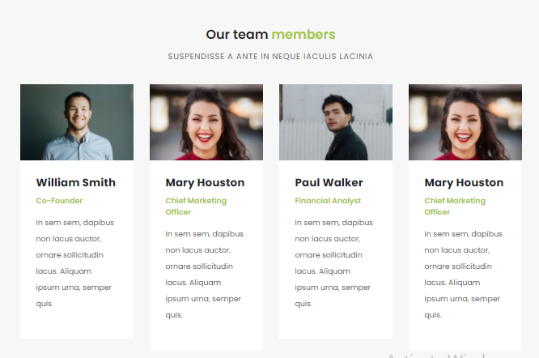

**Our Experts**

**Primedissertation.co.uk** has qualified experts from world-renowned institutions provide their knowledge to assist you in your work and develop high-quality solutions.

**Simon**

I finished my master's degree in nursing, and I am a nurse at the municipal hospital. Over the last six years, I have been working as a nurse. In addition, I worked as a teacher for two years. I use my expertise and skills in producing student nursing papers. I assist those students who encounter problems with the accuracy of their writings.

**Emily**

Over the last three years, I have been a literature expert and have been working with greatassignmenthelp.com. I also work as a literature teacher in a well-known educational institute.

**Howard**

I have done my masters in Human Resources. I have studied at a renowned university, and I have experienced six years in writing.

**Emma**

I completed my bachelor in Biomedical engineering. Since then, I have been working as a writer, and it has been three years that I have been working with this organization. I am special in Critical thinking, introspective writing, and dissertations.

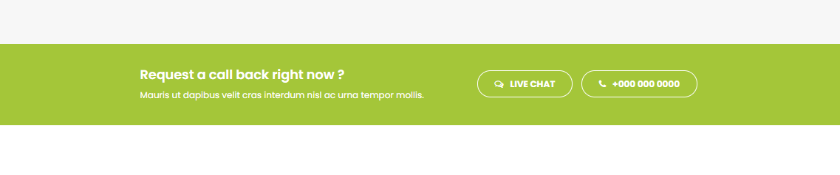

**Want help? You can call us now.**

We are available to help you. So give us a call.

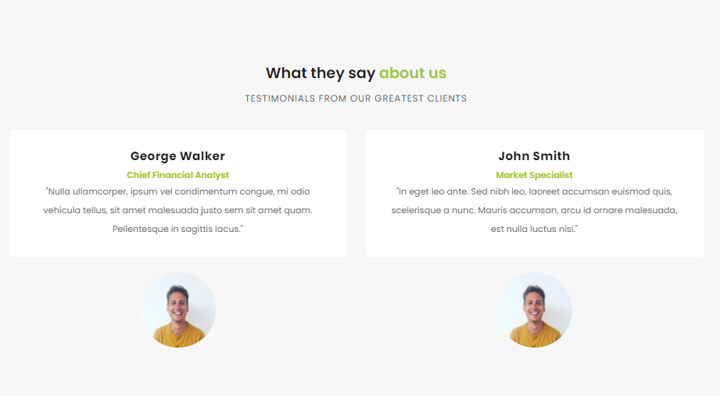

**Amelia**

Dear expert, you've covered every angle of this complex problem. I expect to be quite busy with job and school next term, so I'll need much more of your assistance then. I'll be watching out for you!

**Joanne**

I didn't expect to get so many points on the essay, to be honest. Really, you guys did a fantastic job. I'm happy to report that you're the finest essay helper.

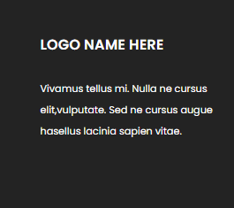

**Disclaimer**

**Primedissertation.co.uk** reference papers are intended to be used as models for students and should not be submitted. The services are solely to be used as study and reference materials.